**Zoom Web SDK – Zoom web chat**

**Create a new messaging queue**

In this section, we will create a new queue that will be used for chat engagements into the Contact Center. In addition to supporting Web Chat, the Messaging queue can also be used for other channels such as SMS and Social Messaging. In this initial lab section, we will focus on the web chat functionality.

**Below 3 options to configure chat in zoom contact center**

1.Queue 🡪 create the queue and add users

2.Flow editor 🡪 design the chat flow in flow editor

3.Web chat Campaign 🡪 create campaign and publish campaign

**1.Queue:**

1. On the Zoom admin portal, login as your Supervisor (Bharath) and navigate to Contact Center Management and click on Queues

2. Click on the top-right corner on + Add queue and set the following values

a. Name → Teleapps

b. Description → Customer Service general messaging queue

c. Channel Type → Messaging d. Click on Save

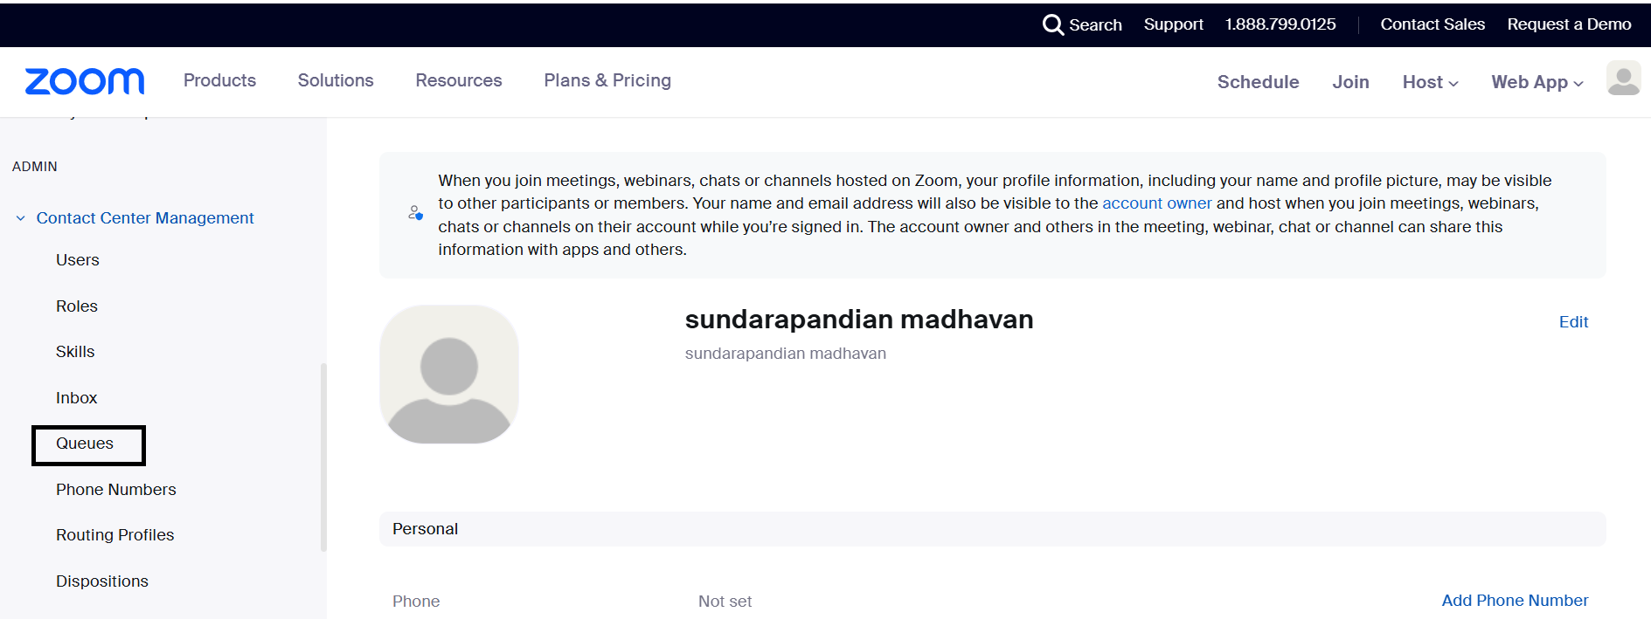

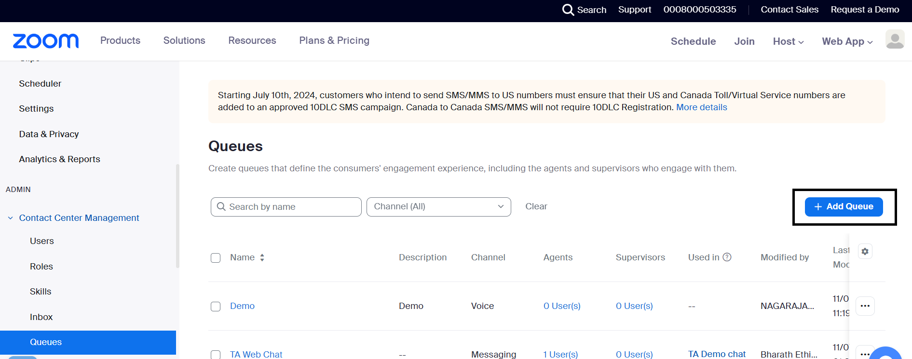

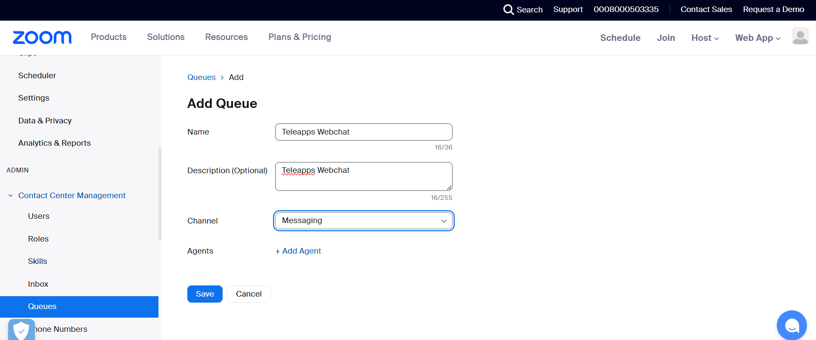

3. The page will refresh to the Queue configuration page, take a moment to review the available settings.

4. In the Assigned Users section,

click the +Add Users link.

On the Assigned Users page, add the pre-configured agent (Sundarapandian) and supervisor (Bharath) to the queue:

a. On the Agents tab, add your agent user

b. On the Supervisors tab, add your supervisor user

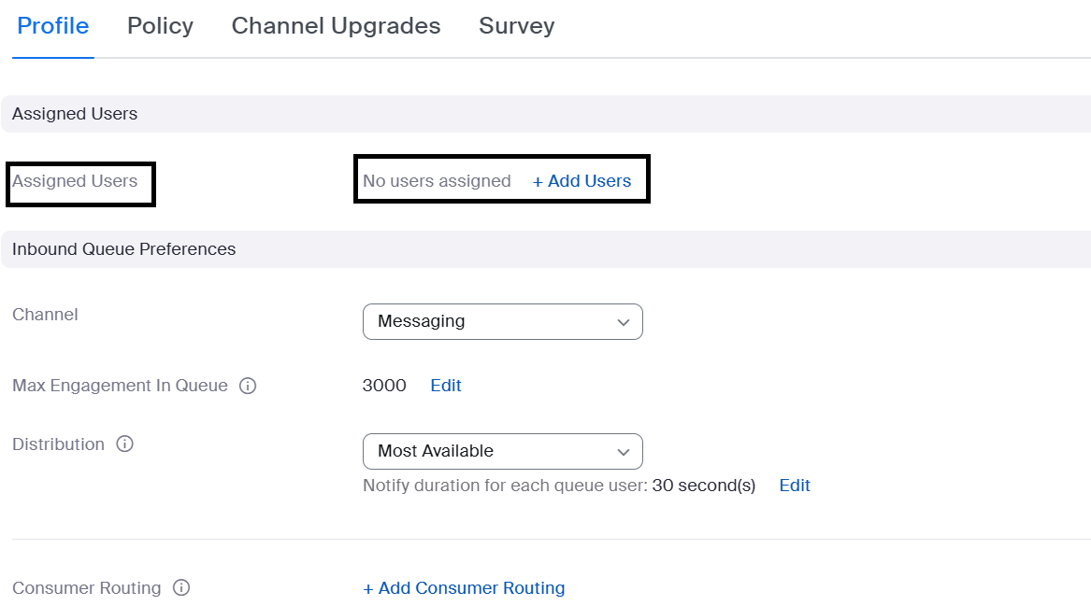

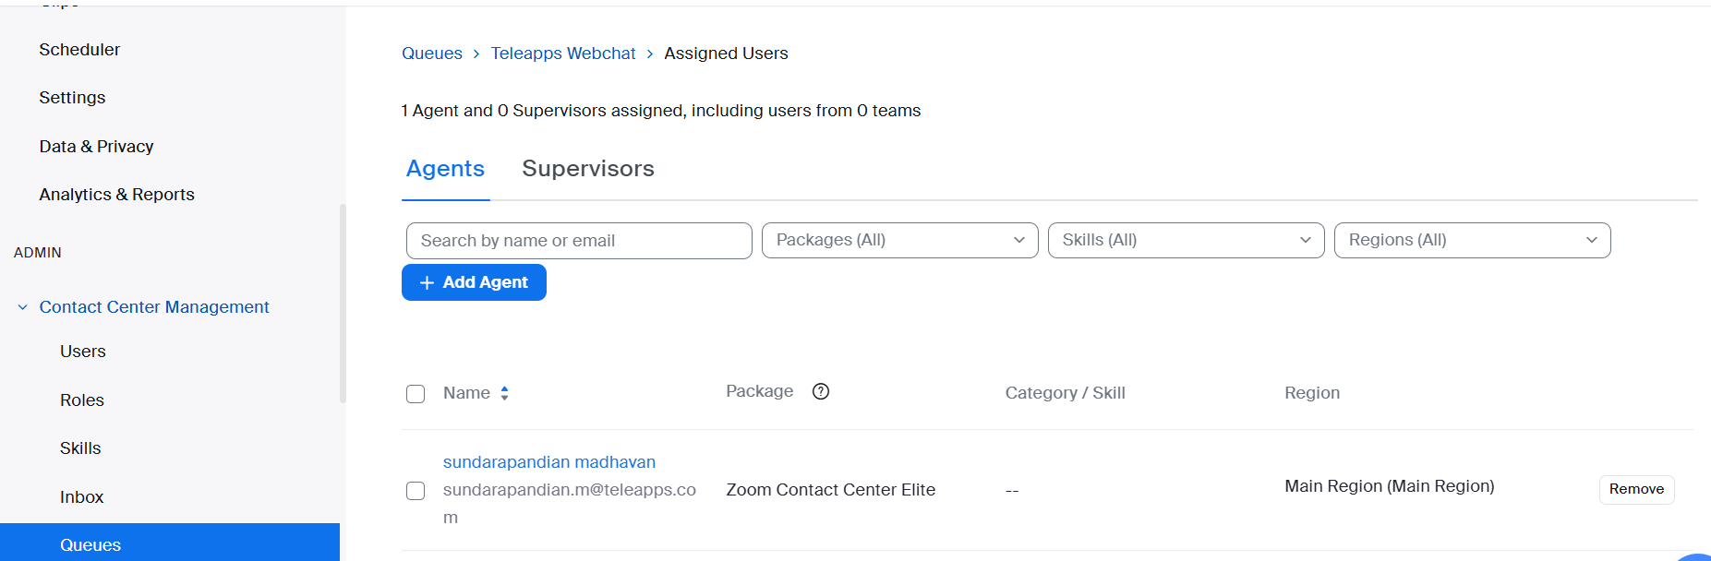

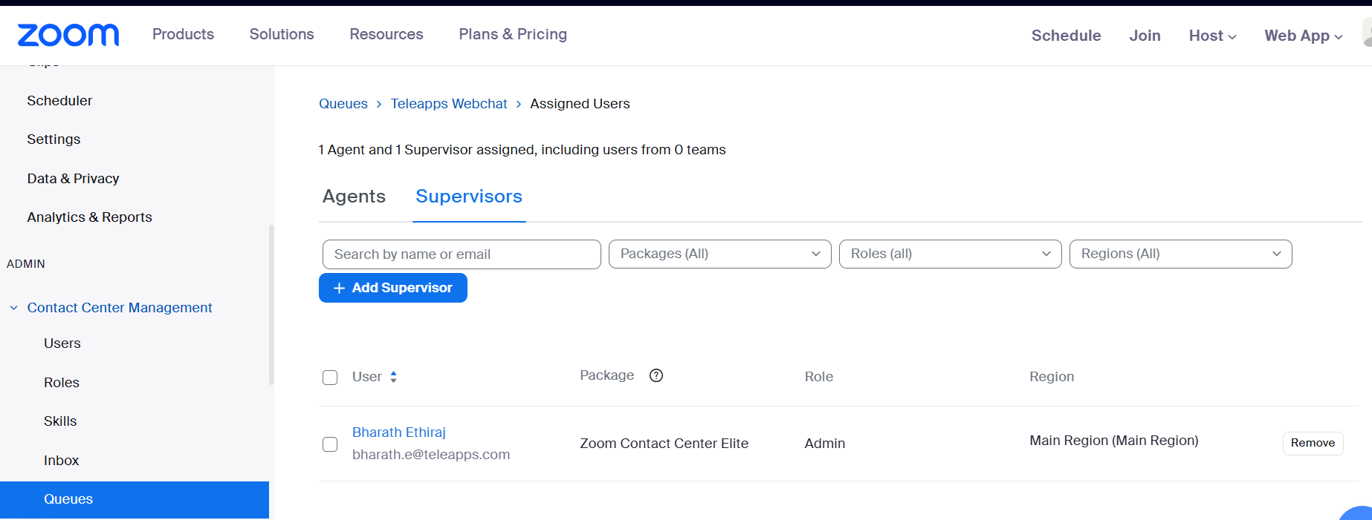

5. Return back to the queue profile page and locate the Inbound Queue Preferences section and review the settings described below:

a. Consumer Routing & Agent Routing - These are two optional features that can be used to implement priority (VIP) call routing and skills based routing, respectively.

b. Accept - By default, the Accept setting is set to Auto. However, you can set it to Manual, which will allow the agent to preview the chat prior to accepting.

let’s change the setting to Manual so that you can experience the inbound call notifications (click Save after changing)

c. Dispositions - Dispositions are used by agents to classify each call with a disposition code. Some dispositions have already been configured on the account, but we now need to assign them to this new queue.

i. Click the +Add Dispositions link

ii. Click the +Add Disposition button

iii. Click the Sets tab

iv. Check the Teleapps Webchat disposition set and click the Add button

v. Return back to the queue Profile page by clicking the queue name at the top of the page.

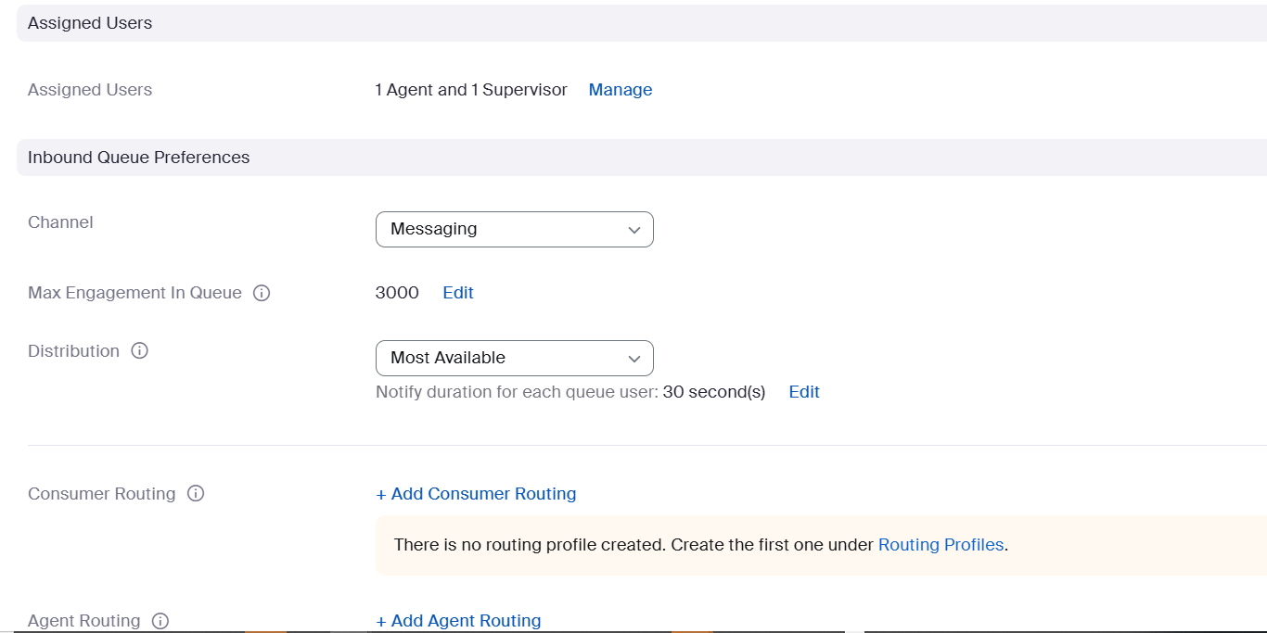

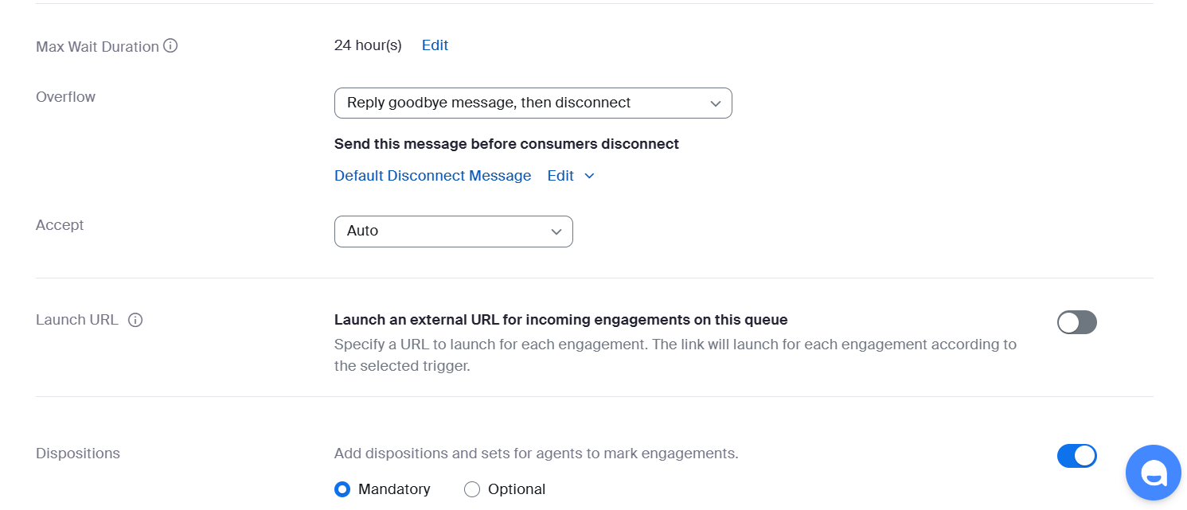

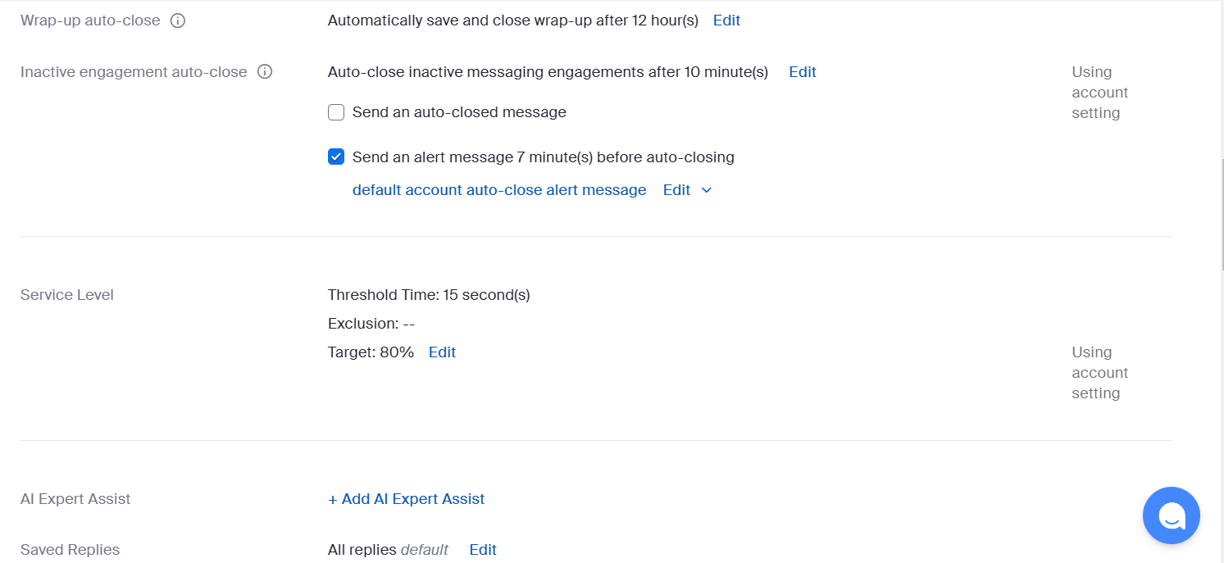

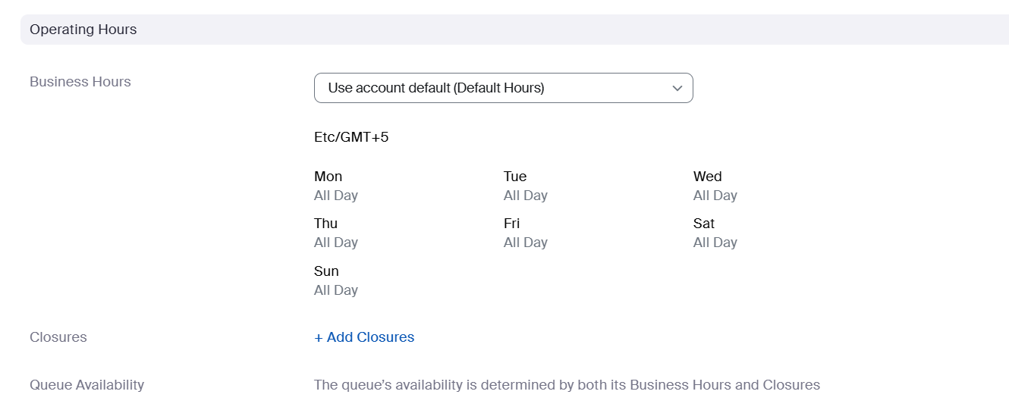

**2.Flow Editor**

**Create a new Web Chat Flow**

Now we need to create a Web chat Flow that will be used to route chat consumers into the queue. The Flow is the core of the ZCC routing engine and allows customization to meet your requirements. This can include using AI chat bots or routing chats directly to a live agent.

1. On the Zoom admin portal, navigate to Contact Center Management and click on Flows

2. Click the Add Flow button and fill out the Add Flow page as described below:

a. Channel: Select the Messaging>Chat (Web) option

b. Name: enter a Name/File Description/Version for your flow (for example: “CS Web Chat ”)

c. Click the Add button

3. A new browser tab will open to the Flow editor and appear as shown. Familiarize yourself with the Flow editor.

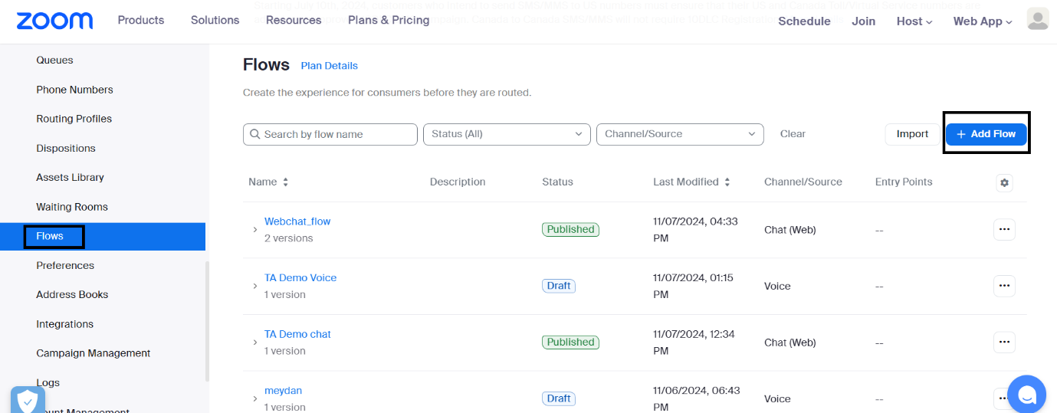

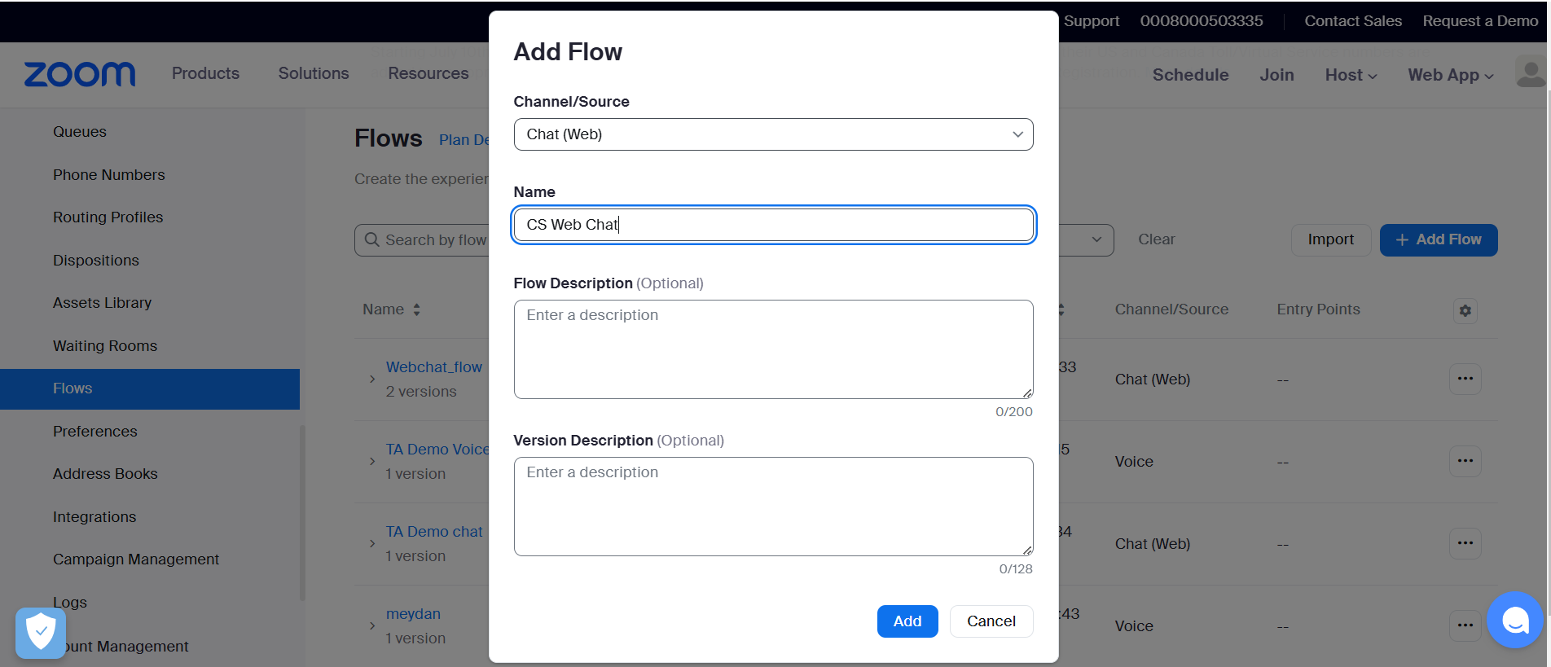

4. Let’s add a welcome prompt to greet our customers. Click and drag a new SendMedia widget onto your flow grid.

a. Once on the flow grid, click on the SendMedia widget,

click Rename and change the name to WelcomeMessage and make the changes below:

1. Media type → Text
2. Text 1 → Thank you for contacting us today.

b. Connect a line from the Start widget to the WelcomeMessage widget

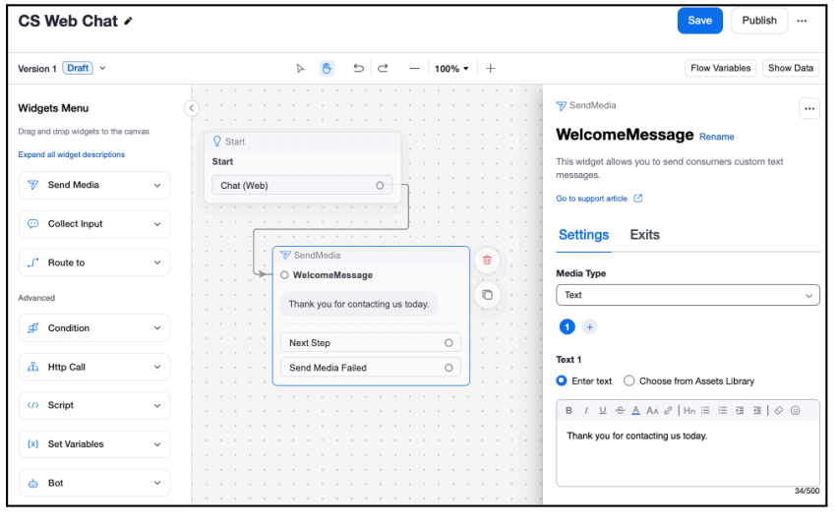

5. Now let’s route the web chat consumer to a queue to get them connected to a live agent.

Click and drag a new Route_to widget onto your flow grid and drop it to the right side of the WelcomeMessage widget.

a. Once on the flow grid, click on the Route_to widget, click Rename and change the name to Queue, then make the changes below:

i. Route To → Queue

ii. Queue → Select the name of the queue you created in the previous section

iii. Notify Estimate Wait Time → Enable this setting and review the default message played to callers to notify them of the expected wait time

b. Connect a line from the WelcomeMessage widget to the Queue widget.

6. At this point, you should have a Flow similar to the one shown above

7. Now we need to publish the flow so it can accept chat engagements. Click the Save button at the top-right of the flow. 8. Once the flow is saved, click the Publish button at the top-right. You have now completed a simple web chat deployment.

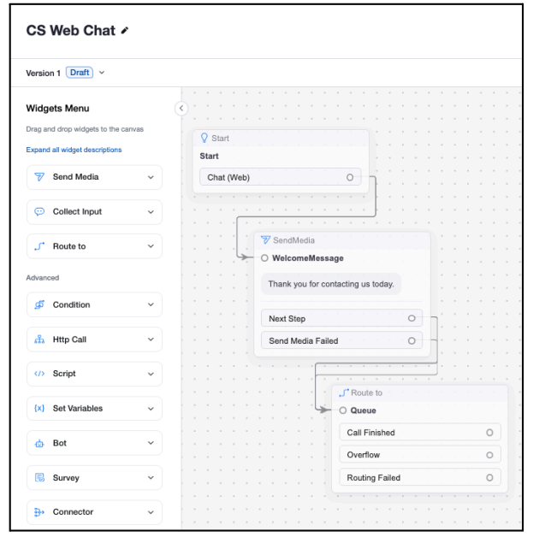

**3.Web Chat Campaign**

Create a Web Chat Campaign

1. Navigate to the Contact Center Management > Campaign Management menu option

2. On the Web and In-App tab, click the + Add Campaign Button

3. When prompted for the campaign type select Chat (Web) and click Add

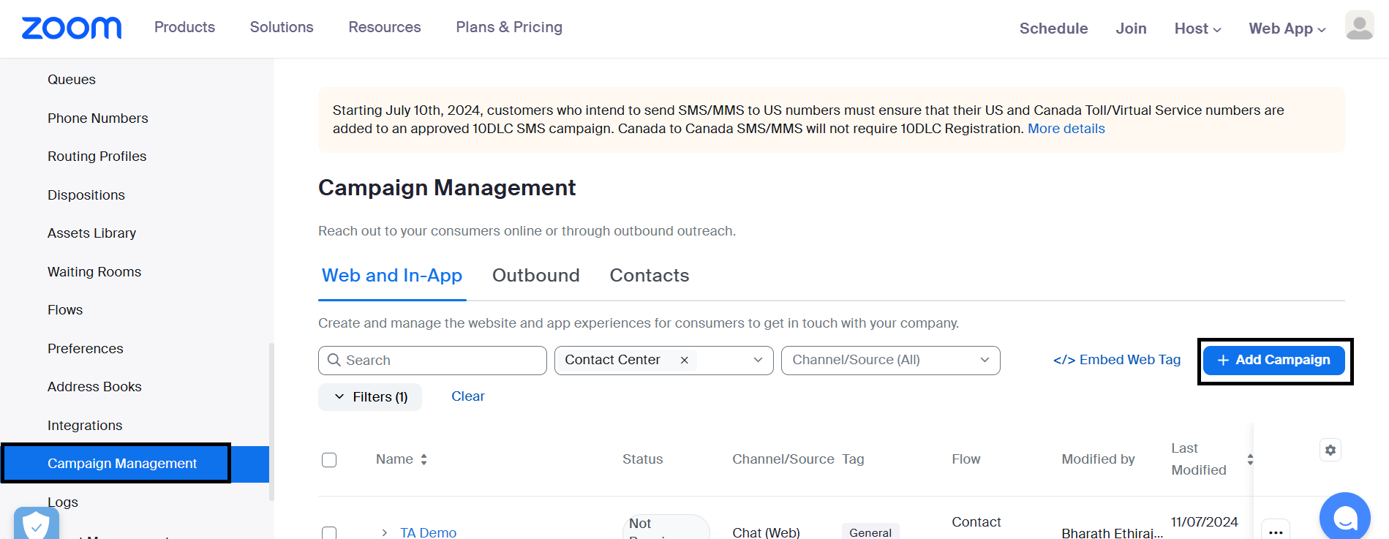

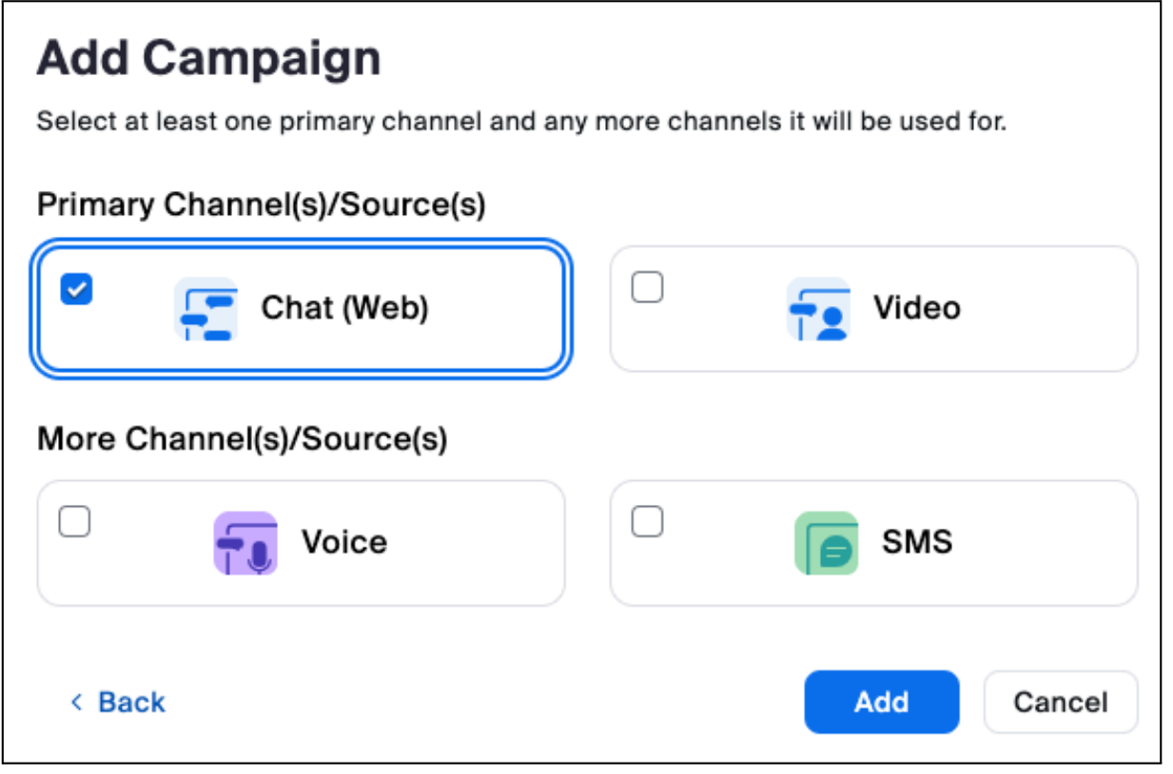

4. Once on the Add Campaign page, complete the settings below:

a. Name: Web Chat

b. Language: Single Language - English (UK) (or another language of your preference)

c. Tag: If you have any existing tags you can select one of those, otherwise:

i. Click the drop down and select Edit Tags

ii. Click + Add a Tag

iii. Enter General and press Enter (you should see your tag change to General (Default)

iv.Click Save

d. Web Chat Flow or Bot:

Select the webchat flow you previously created (if you do not see it listed, return to your flow and confirm that it was published)

e. Start Date: Select yesterday’s date

f. End Date: You can leave this blank

g. Time Zone: Select your time zone

5. Scroll down to the Invitation section and click the + Create Invitation link. On the create invitation page, customize the chat invitation to your liking.

a. Name: Chat button

b. Customization: Experiment with the options available and create a button that will be used to initiate a chat engagement.

c. Click Save once you are happy with your invitation button

6. Back on the Campaign screen, in the Invitation section, select and highlight the new invitation you just created.

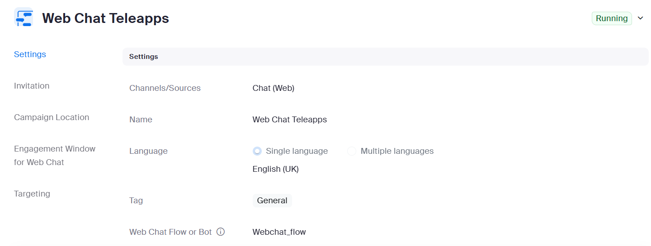

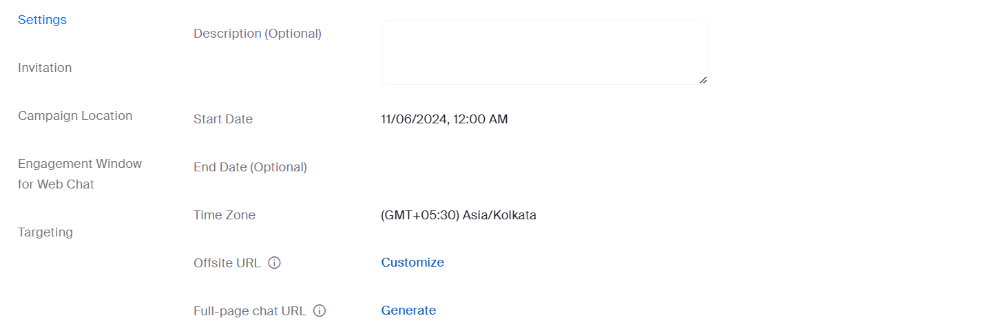

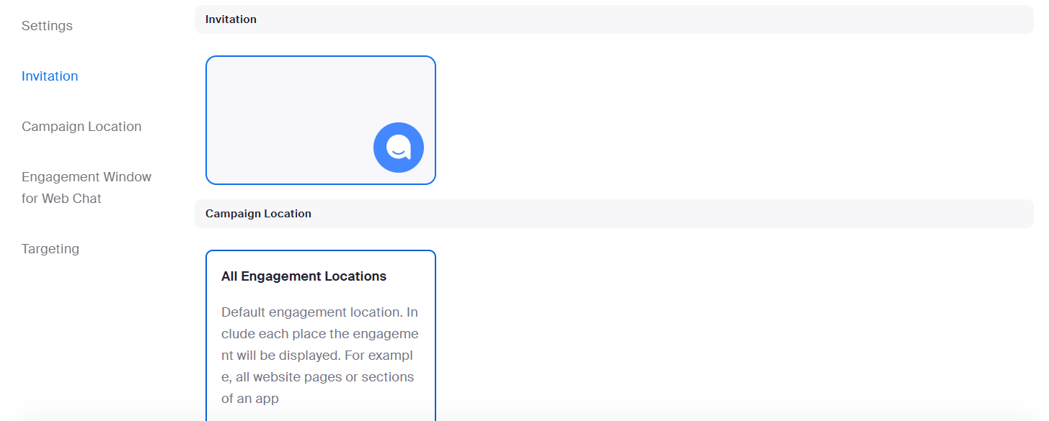

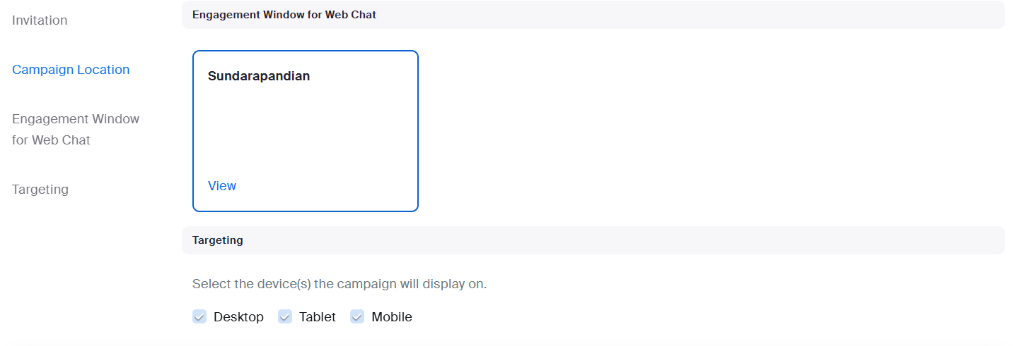

7. Scroll down to the Campaign Location section and click the + Create Campaign Location link. In the new campaign location window, configure the settings below:

a. Name: Web Chat Location

b. Location Type: Page (URL/query string)

c. Define where the campaign can be displayed: webchatcp(Each Location need to change the name)

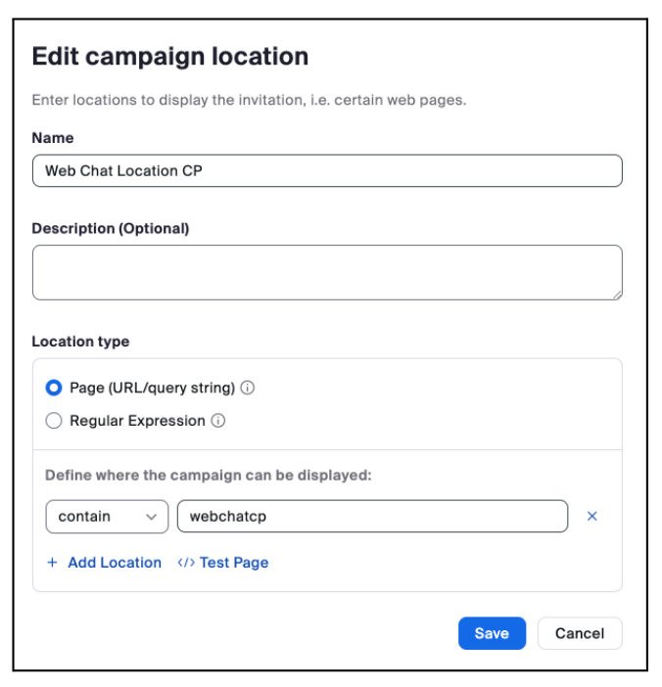

8. Back on the Campaign screen, in the Campaign Location section, select and highlight the new invitation you just created.

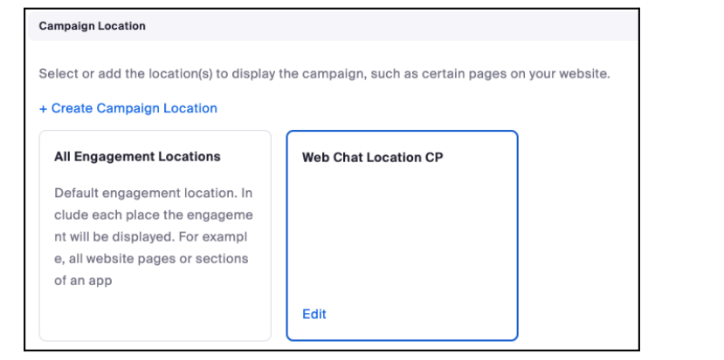

9.Scroll down to the Engagement Window for Web Chat section and click the + Create Engagement Window link. On the Add Engagement Window page, customize the chat engagement window to your liking.

a. Click on the Design tab i. Name: Chat Engagement Window ii. Experiment with the remaining customization capabilities to modify the engagement window. You can customize the colors and fonts as well as add a Header Text

b. Click on the Welcome Screen tab

i. Enable the welcome screen checkbox.

ii. The welcome screen is used to collect information from the consumer when they are starting a chat. Experiment with customizing the look and feel of the Welcome Screen.

iii. Scroll down to the Fields section and enable the checkboxes for the fields below. You can also select the checkboxes to make these fields mandatory to ensure they are populated by the consumer.

1. First name

2. Last name

3. Email address

iv. Once you have enabled the Welcome Screen fields, click the Save button.

10. Back on the Campaign screen, in the Engagement Window for Web Chat section, select and highlight the new Engagement Window you just created.

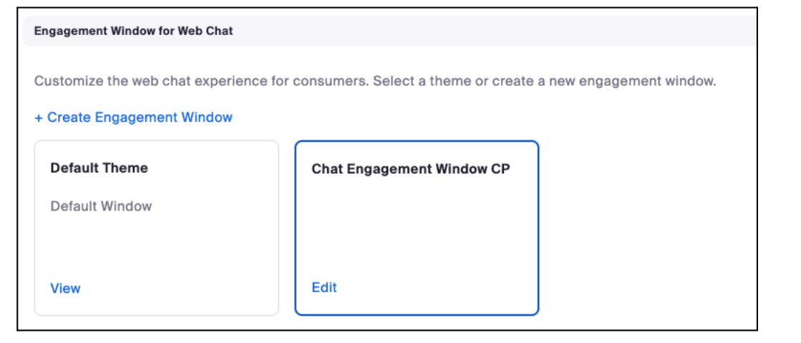

11. Scroll down to the Targeting section, you can control whether the chat invitation for this campaign appears based on the User Agent of the consumer’s web browser. For example, if you do not want to offer this campaign on smart phones, you should uncheck the Mobile checkbox.

Embedding the Campaign on a website

1. Return to the Contact Center Management > Campaign Management menu option

2. Click on the Embed Web Tag link

3. Note the javascript web tag code snippet. You will use the API key in the steps below

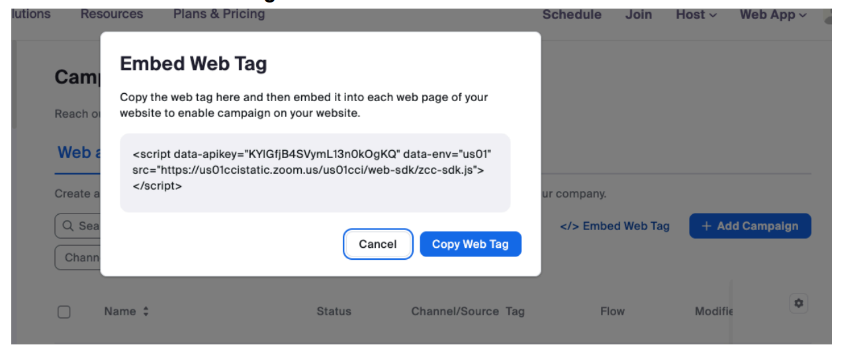

4. In order for your chat invitation button to appear, you must append the Location setting that you configured previously to your URL. See an example in the screenshot below with the Campaign Location value of webchatcp appended to the end of the URL as a query parameter.

5. <script data-apikey="bbjoydyxT9iZMH_VhR_7vw" data-env="us01" src="https://us01ccistatic.zoom.us/us01cci/web-sdk/zcc-sdk.js"></script>

I have created sample html webpage with below script

<!DOCTYPE html>

<html lang="en">

<head>

<meta charset="UTF-8">

<meta http-equiv="X-UA-Compatible" content="IE=edge">

<meta name="viewport" content="width=device-width, initial-scale=1.0">

<title>Zoom Web SDK Integration</title>

</head>

<body>

<h1>Zoom Web SDK Integration Example</h1>

<p>This is a simple webpage to demonstrate how to include the Zoom Web SDK.</p>

<!-- Include the Zoom Web SDK JavaScript -->

<script

data-apikey="bbjoydyxT9iZMH_VhR_7vw"

data-env="us01"

src="https://us01ccistatic.zoom.us/us01cci/web-sdk/zcc-sdk.js">

</script>

<!-- Additional content or scripts can go here -->

</body>

</html>

**Chatting with an agent**

1. If you are not already logged in to the Zoom client, log in now using your Contact Center agent credentials.

2. Click on the Contact Center button on the top of the Zoom client, click Start if you’re asked to start your Work Session, then make sure you are set to Ready as shown below.

3. Now it's time to test! You should have the chat engagement alerting on your desktop client. Answer the chat engagement

4. While connected to the chat, explore the desktop client

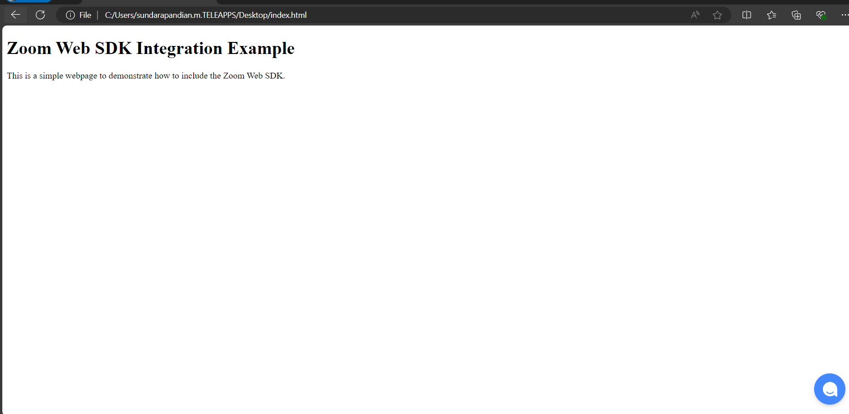

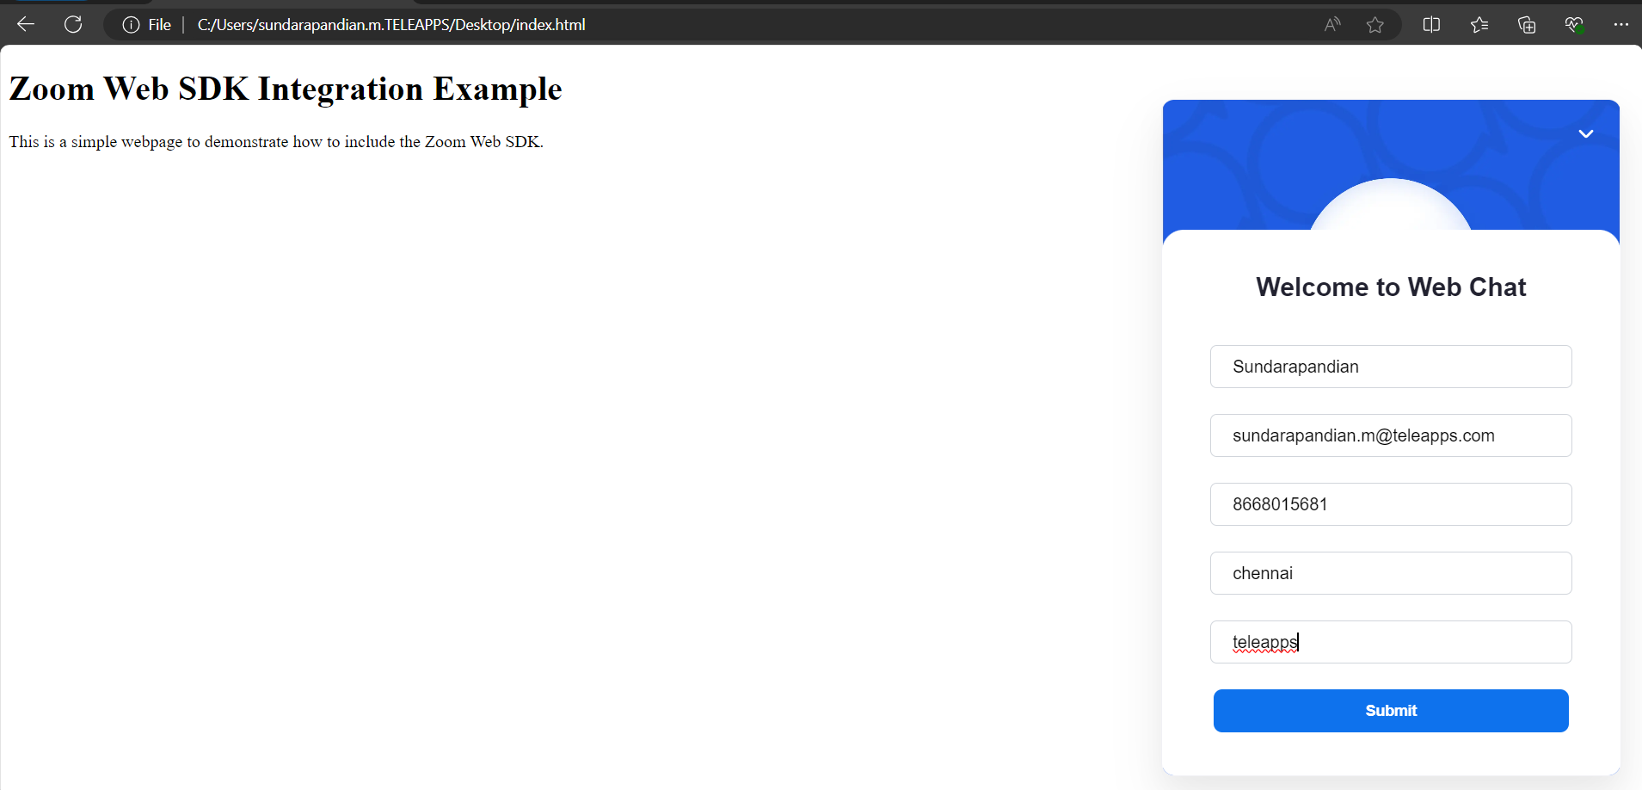

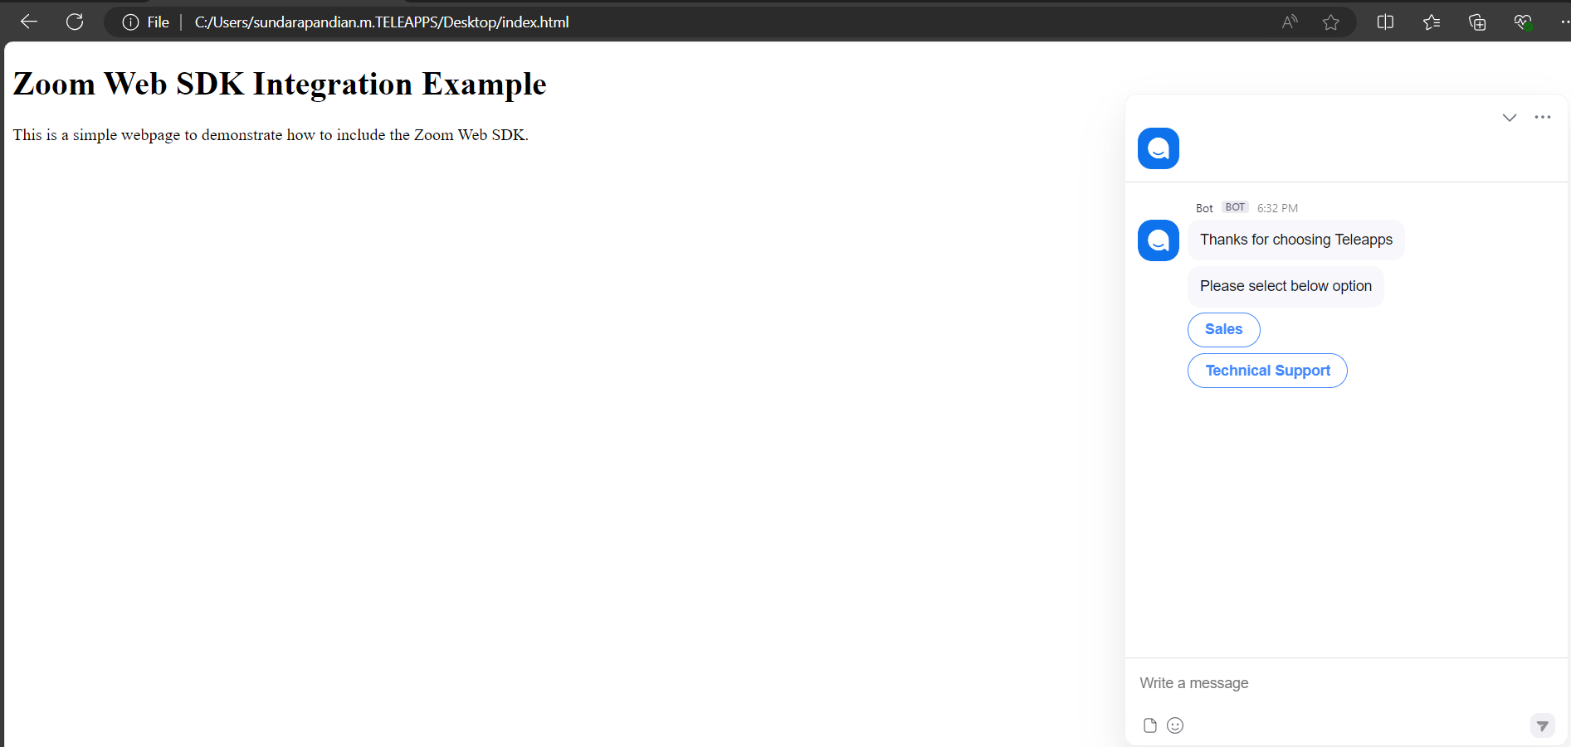

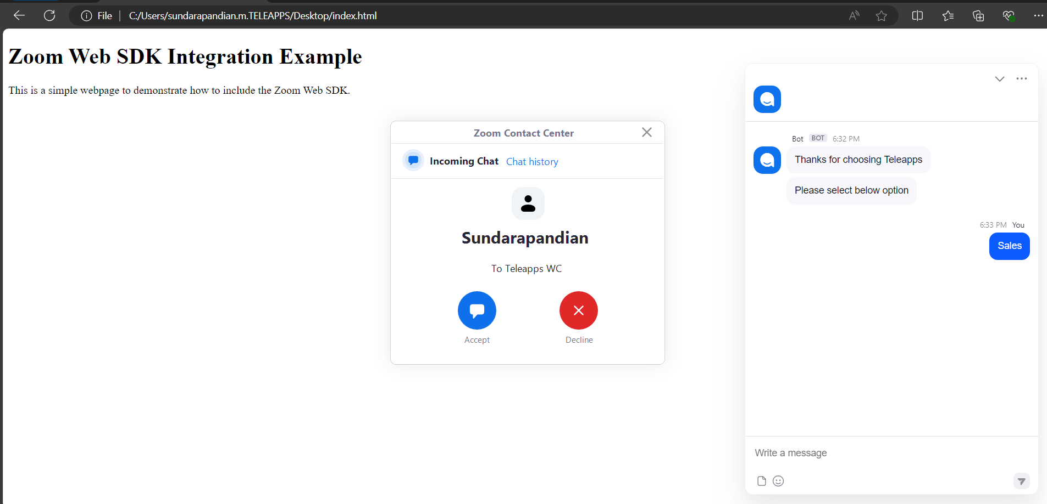

Click “Accept”

Zoom chat panel

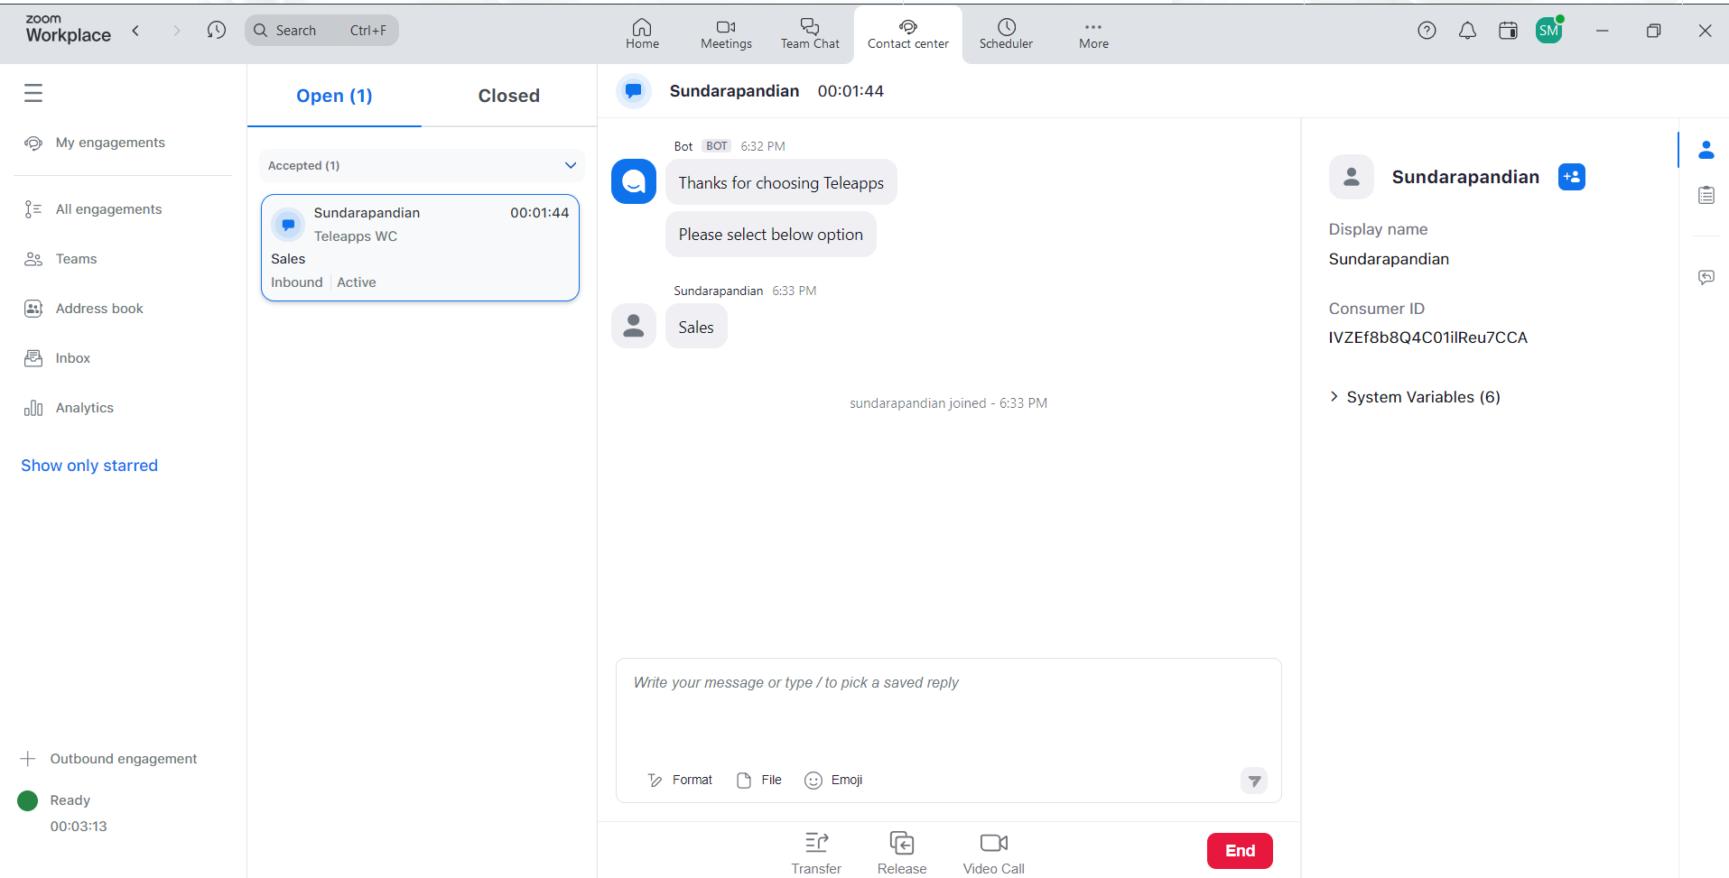

**Routing Profile**

In Queue have two routing profile

1.Consumer routing Profile

2.Agent routing profile

1.Consumer routing profile:

Consumer routing profiles allow admins to configure how customers are routed based on customer attributes like whether they're a new or returning customer. Consumer routing happens before [agent routing](https://support.zoom.us/hc/en-us/articles/4423969634317).

**Prerequisites for managing consumer routing profiles**

* Account owner or admin privileges
* Pro, Business, or Education account
* Zoom Contact Center license

Types of Consumer routing profile

1.FIFO (First IN First Out):

By default, Zoom Contact Center uses a FIFO consumer routing method. This means consumers are routed based on the time they entered the queue. Consumers that enter earlier are routed to an agent earlier. Customers are not prioritized in any way.

2.Top Prioirty

Top Priority prioritizes specific customers based on attributes like if they are a new or returning consumer. For example, you can configure a consumer routing profile so that new customers are prioritized.

3.Accumulating Priority

Accumulating Priority prioritizes consumers based on their time waiting in the queue. Consumers accumulate priority while waiting in the queue, so consumers in the queue longer will be prioritized. Accumulating Priority is used together with Top Priority, meaning you can configure certain consumers to accumulate priority at a high rate, while consumers with Top Priority still have higher priority.

Notes:

* When an agent is assigned to multiple queues with a consumer routing profile, priority customers will be served first. Same Priority customers will be served using FIFO.
* If 2 customers have the same weight within the same queue at time of service, priorities are based on highest priority and round robin**.**

How to create a routing profile

1. Sign in to the Zoom web portal.
2. In the navigation menu, click Contact Center Management then Routing Profile.
3. Click the Consumer tab.
4. Click Add Consumer Profile.
5. Enter the following information:
   * Name: Enter a display name to help identify the routing profile.
   * Description (optional): Enter a description.
6. Click Save.  
   The new routing profile will be added to the Routing Profile page**.**

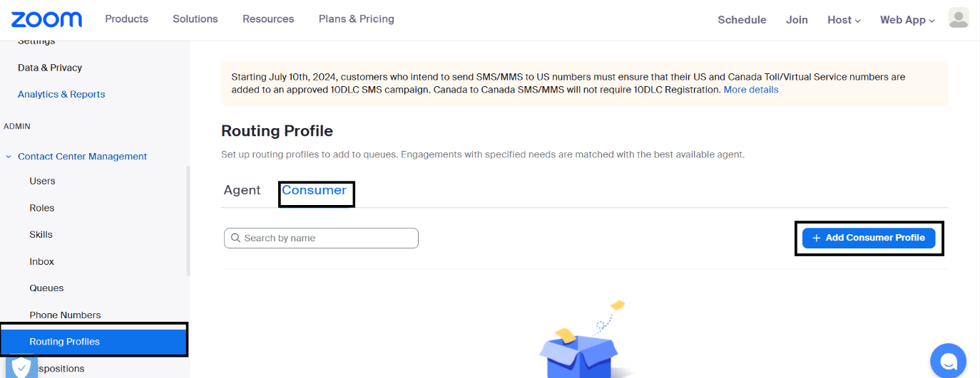

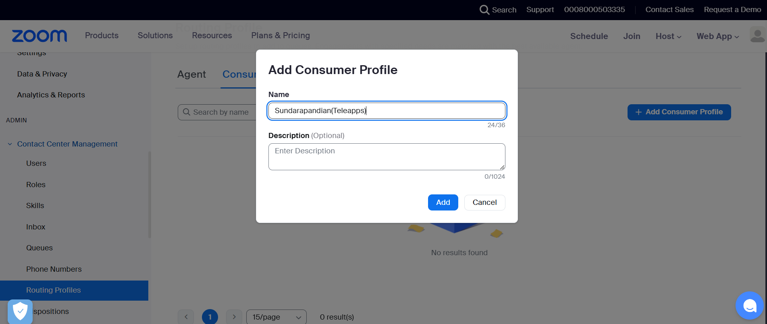

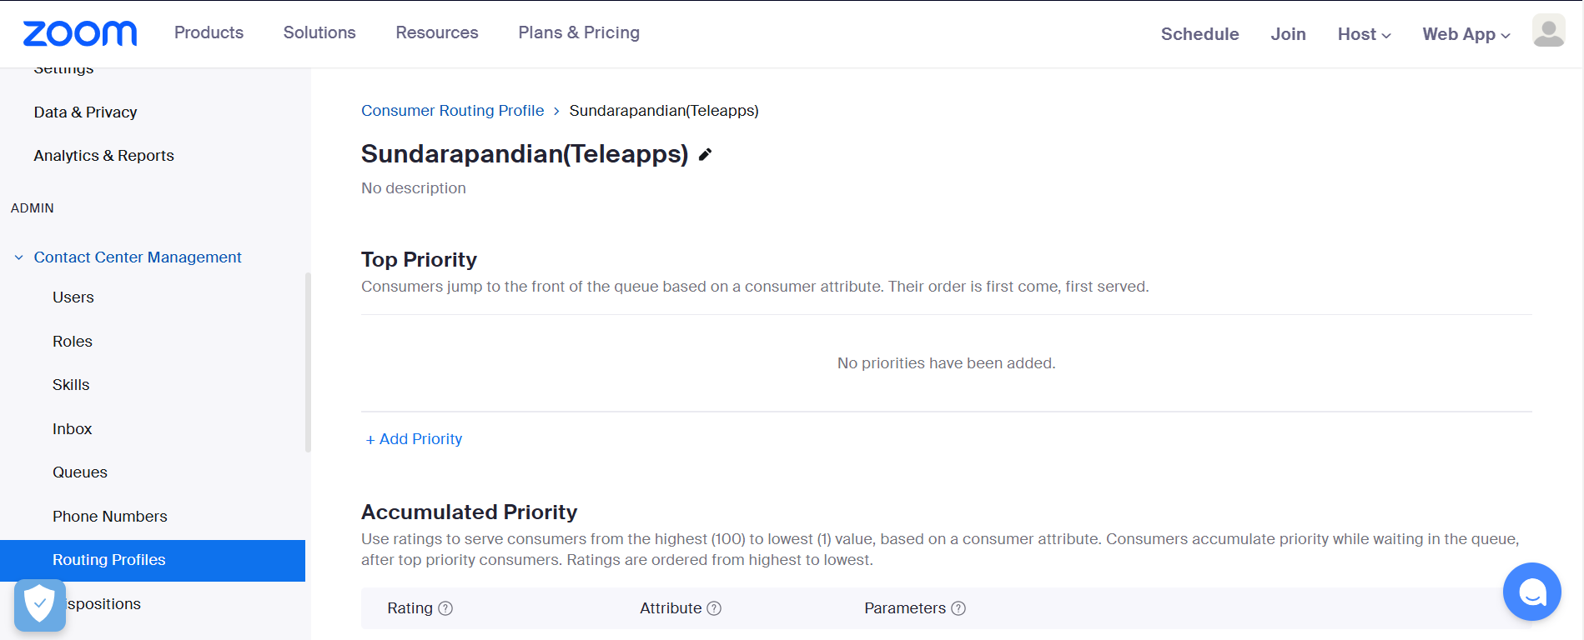

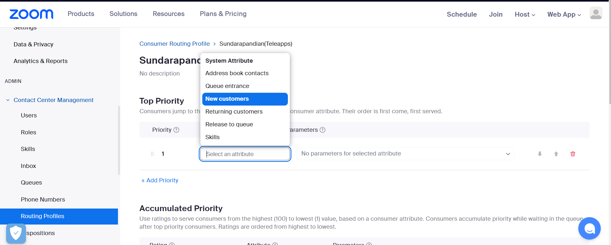

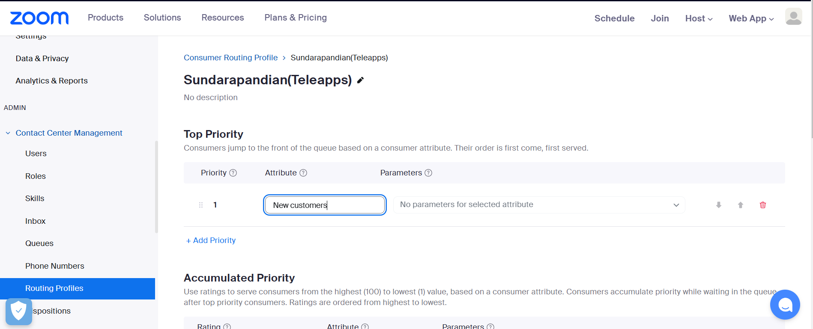

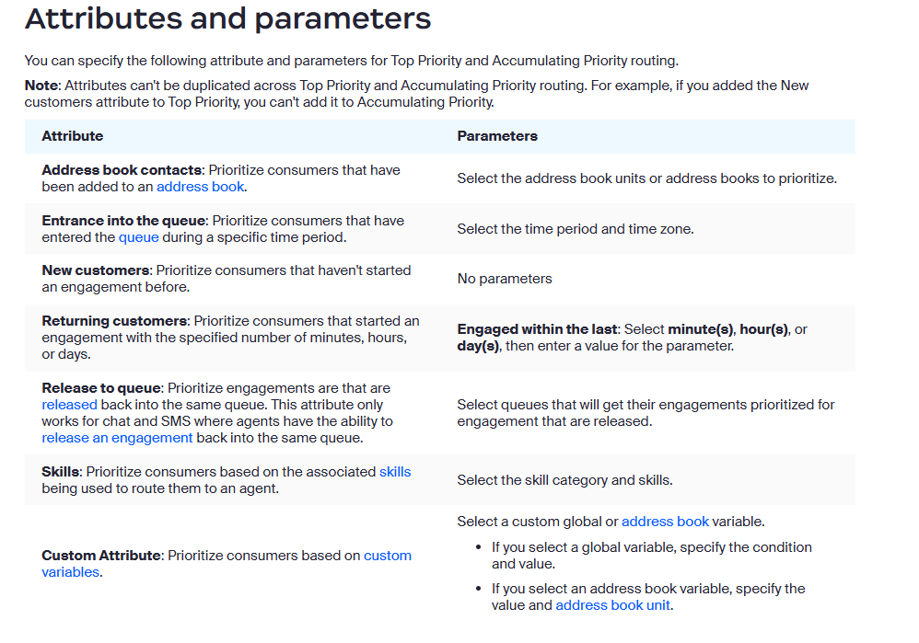

How to configure Top Priority routing

Repeat these steps to add priorities to a routing profile.

1. Sign in to the Zoom web portal.
2. In the navigation menu, click Contact Center Management then Routing Profile.
3. Click the Consumer tab.
4. Click the display name of the routing profile you want to edit.
5. Under Top Priority, click Add Priority.
6. Specify the [Attribute and Parameters](https://support.zoom.com/hc/en/article?id=zm_kb&sysparm_article=KB0059249#h_01G14B1E7SSSG2P26P7Y424YVG) for the priority.
7. (Optional) Follow steps 5 and 6 to add more priorities.
8. (Optional) [Rearrange the priorities](https://support.zoom.com/hc/en/article?id=zm_kb&sysparm_article=KB0059249#h_01FWHEF417A9FJJ98RMVNHNTCJ).
9. Click Save

**How to configure Accumulating Priority routing**

1. Sign in to the Zoom web portal.
2. In the navigation menu, click **Contact Center Management** then **Routing Profile**.
3. Click the **Consumer** tab.
4. Click the display name of the routing profile you want to edit.
5. Under **Accumulating Priority**, click **Add Priority**.
6. Specify the following options for the priority:
   * **Rating**: Specify a rating from 1 to 100. The same rating value can be used for different attributes. A rating of 10 is assigned to all unspecified consumers who do not match other accumulated priority attributes. A higher rating means the associated consumer group will accumulate priority at a faster rate.
   * Specify the [**Attribute** and **Parameters**](https://support.zoom.com/hc/en/article?id=zm_kb&sysparm_article=KB0059249#h_01G14B1E7SSSG2P26P7Y424YVG) for the priority.
7. (Optional) Follow steps 5 and 6 to add more priorities.
8. (Optional) [Rearrange the priorities](https://support.zoom.com/hc/en/article?id=zm_kb&sysparm_article=KB0059249#h_01FWHEF417A9FJJ98RMVNHNTCJ).
9. Click **Save**.

**Managing agent routing profile:**

Zoom Contact Center admins can add and edit routing profiles. Routing profiles route engagements to the appropriate agents that can best meet their needs based on previously-created skills. Each routing profile can contain a combination of skills that are prioritized. A higher proficiency rating means an agent is better at that skill.

For example, if you previously created a language and warranty skill category, you can create a routing profile to route engagements based on language proficiency and whether agents are able to process warranties. This list illustrates a routing profile with priorities and skills.

1. English skill (level 3 or higher proficiency)
2. English skill (level 2 or higher proficiency)
3. Warranty skill

After creating a routing profile, you can assign it to a [queue](https://support.zoom.us/hc/en-us/articles/4469989300493) so that inbound engagements are routed accordingly. When agents transfer a [voice](https://support.zoom.us/hc/en-us/articles/4470793859725) or [SMS](https://support.zoom.us/hc/en-us/articles/7794750221453) engagement to a queue with an agent routing profile, they can specify the associated skills so that the engagement is routed accordingly.

**Prerequisites for managing routing profiles**

* Account owner or admin privileges
* Pro, Business, or Education account
* Zoom Contact Center license

**How to create a routing profile**

1. Sign in to the Zoom web portal.
2. In the navigation menu, click **Contact Center Management** then **Routing Profile**.
3. Click the **Agent** tab.
4. Click **Add Agent Profile**.
5. Enter the following information:
   * **Name**: Enter a display name to help identify the routing profile.
   * **Description (optional)**: Enter a description.
6. Click **Save**.  
   The new routing profile will be added to the Routing Profile page.

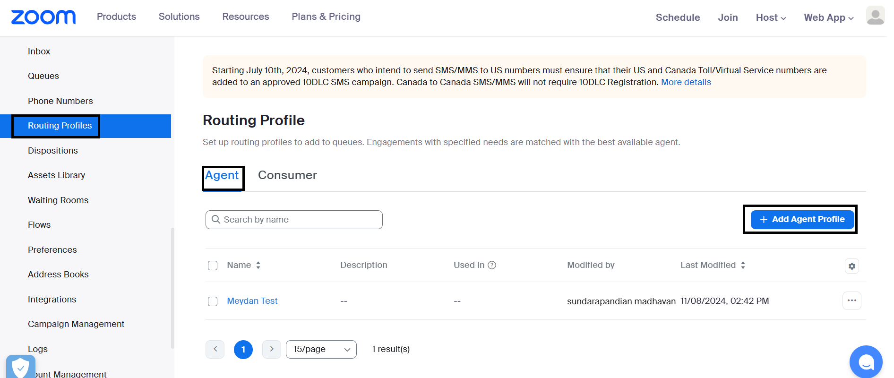

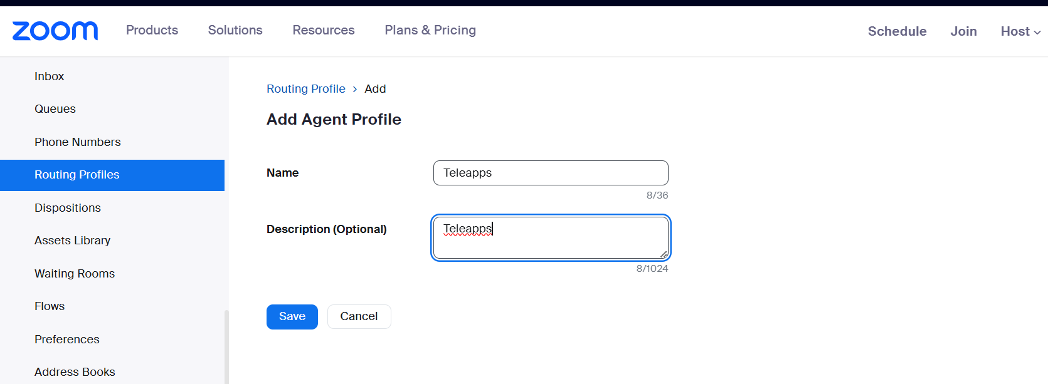

**How to set the wait time for matched agent availability**

1. Sign in to the Zoom web portal.
2. In the navigation menu, click **Contact Center Management** then **Routing Profile**.
3. Click the display name of the routing profile you want to edit.
4. At the top of the page, enter a value in seconds next to **Wait time for matched agent availability**.

**How to add a priority and conditions to a routing profile**

Repeat these steps to add additional priorities to a routing profile.

1. Sign in to the Zoom web portal.
2. In the navigation menu, click **Contact Center Management** then **Routing Profiles**.
3. Click the **Agent** tab.
4. Click the display name of the routing profile you want to edit.
5. Click **Add Priority**.
6. Specify the following options for the priority:
   * **Select a category**: Select an existing [skill category](https://support.zoom.us/hc/en-us/articles/4423986613261).
   * **Minimum Proficiency** (optional): If the skill category is for proficiency-based skills, select the maximum proficiency level for the skill category. Agents must have the minimum proficiency level or higher for engagements to be assigned to them. A higher proficiency rating means an agent is better at that skill.
   * **Required**: Specify if the skill category is required. If required, agents must have the corresponding skill for engagements to be assigned to them.
7. (Optional) Follow steps 5 and 6 to add more priorities.
8. (Optional) [Rearrange the priorities](https://support.zoom.com/hc/en/article?id=zm_kb&sysparm_article=KB0060893#h_01FWHEF417A9FJJ98RMVNHNTCJ).
9. Click **Save**.

Operation hours Flow Chart:

